**Deploy a Spring Boot Application in Azure App Service**

Perquisites:

* An Azure Subscription
* A Spring Boot Application
* A GitHub repository

**Step#1 : We need go to the Azure portal and click on click on Azure Cloud Shell like below.**

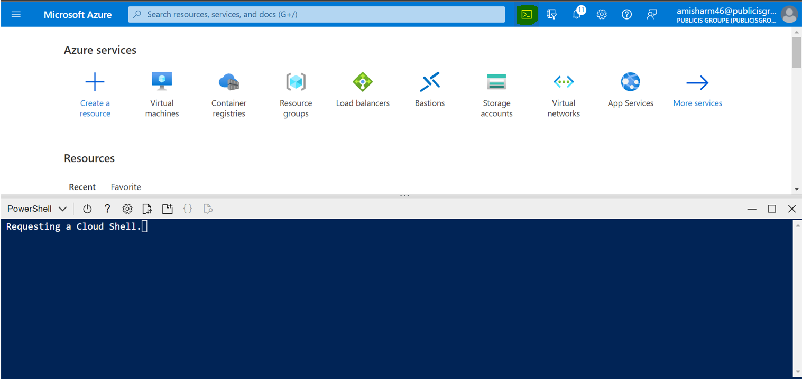

**Step#2 : Now we have to go to our remote repository and copy the url to clone the application.**

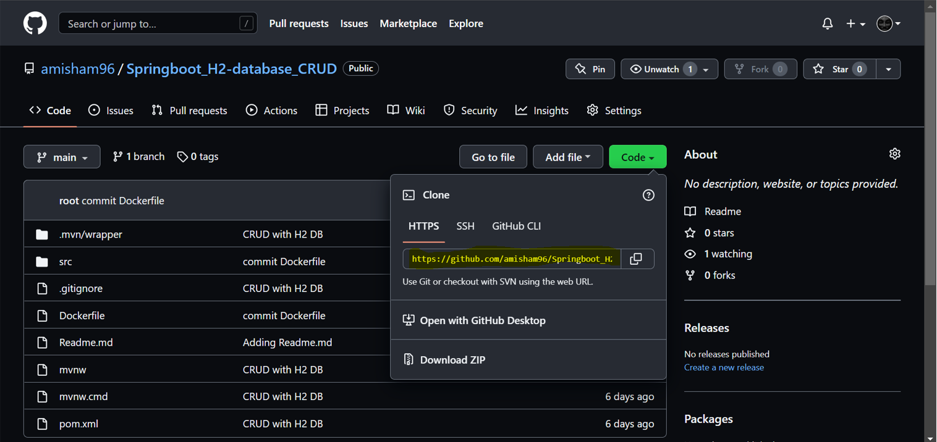

**Step#3 : After that go to Azure cloud shell and clone the code using below command.**

**“git clone** [**https://github.com/amisham96/Springboot_H2-database_CRUD.git**](https://github.com/amisham96/Springboot_H2-database_CRUD.git)**”**

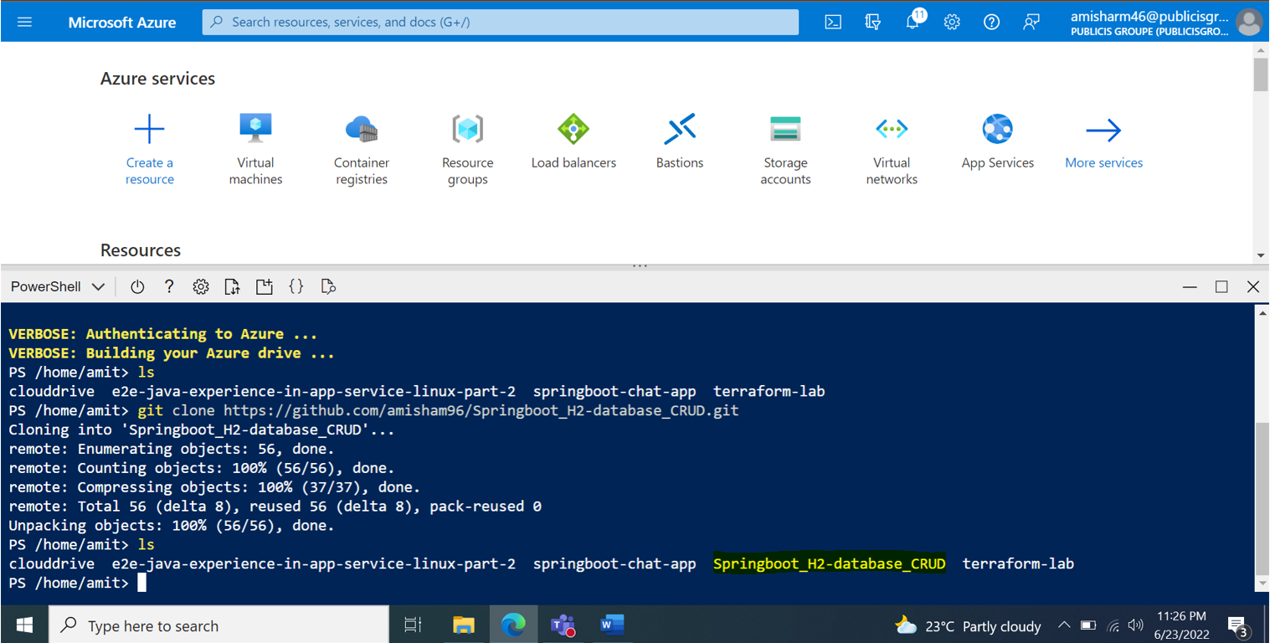

**Step#3 : Now go inside the cloned directory using cd command. And use ‘ls’ command to check the directory and list down the files.**

**“cd Springboot_H2-database_CRUD” “ls”**

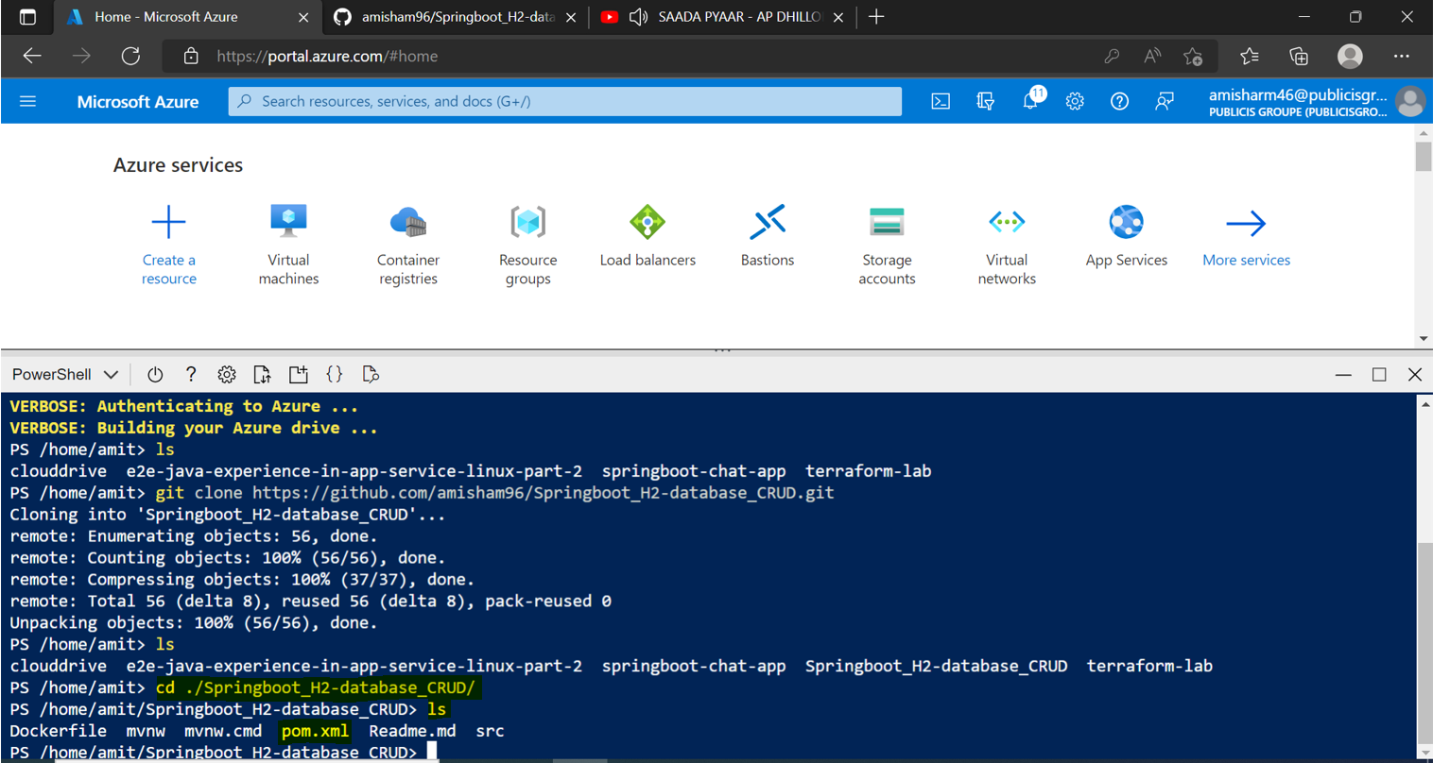

**Step#3 : After that we have to compile the maven package and add some configurations before deploying application. Use below to command to compile and configure the environment**

**“mvn com.microsoft.azure:azure-webapp-maven-plugin:2.5.0:config”**

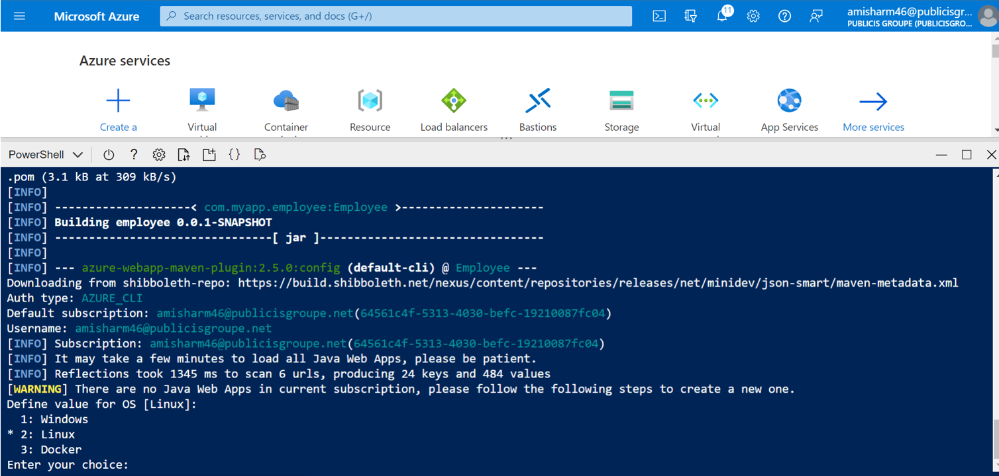

**After selecting the OS we have to select the Java version like below**

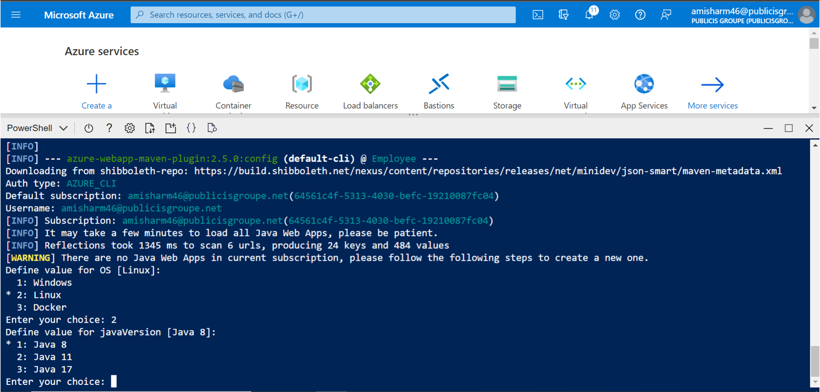

**After selecting the java version we have to configure the pricing tier**

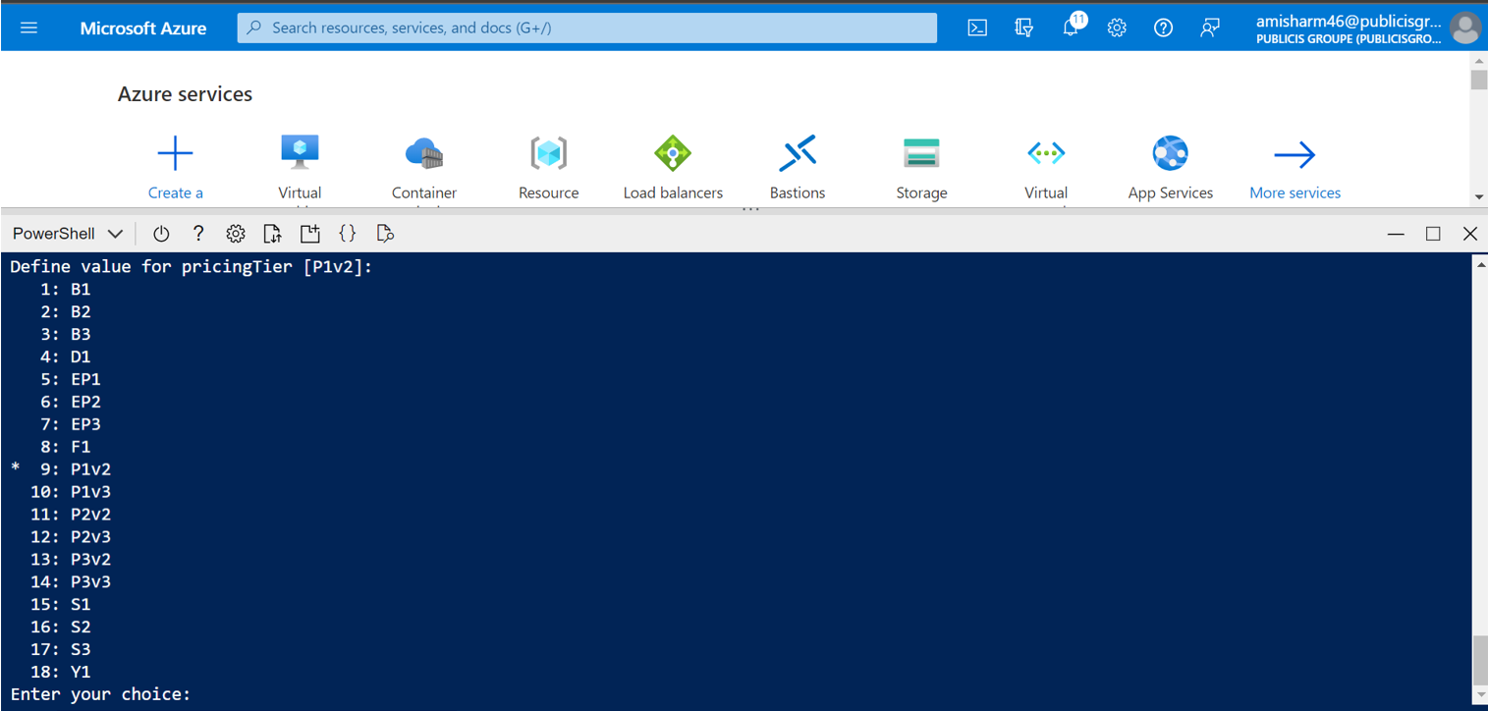

**After entering the choice it will start compiling and building the application but here we have not configure the resource group, location, app name we again need to run the same command**

**“mvn com.microsoft.azure:azure-webapp-maven-plugin:2.5.0:config”**

**After running the command it will ask for application type and after application type it will ask an application name**

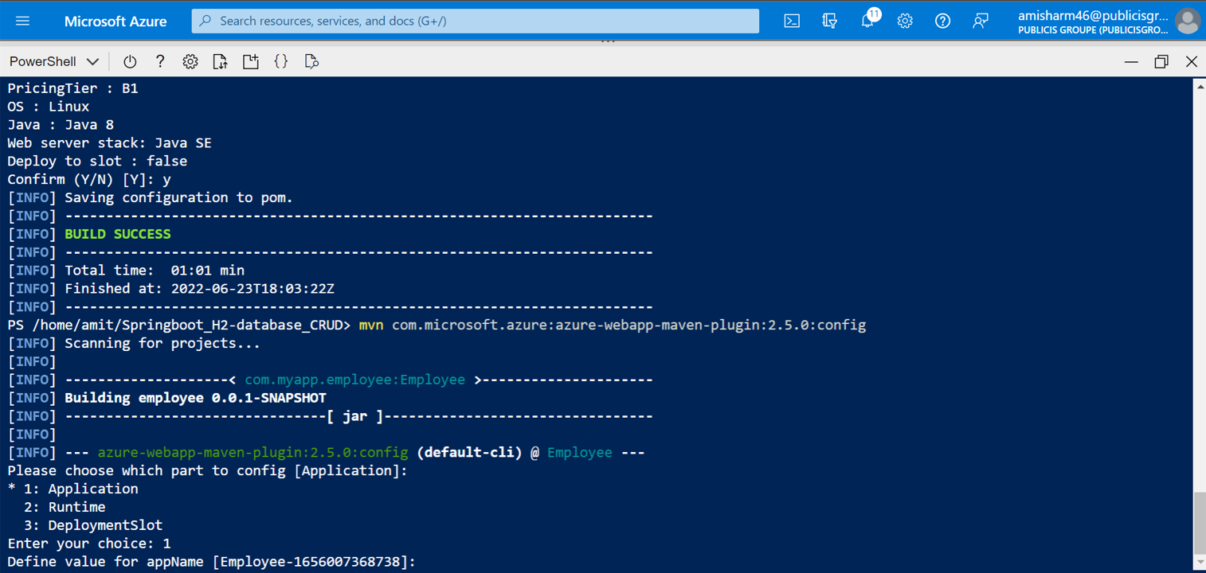

**After giving the app name it will ask for resource group name like below**

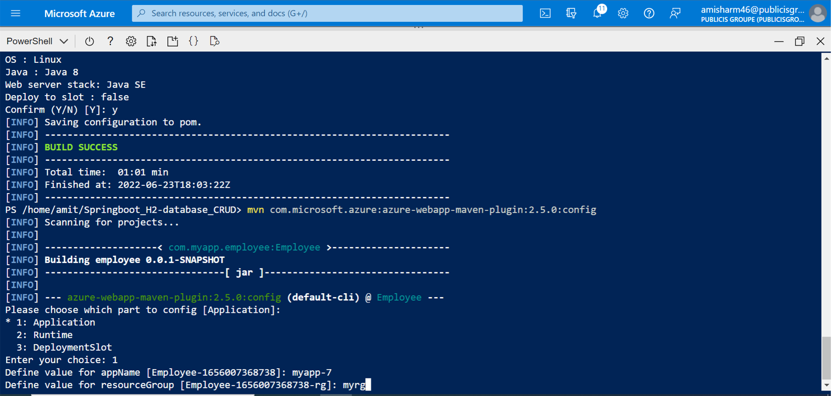

**After entering resource group name it will ask for location**

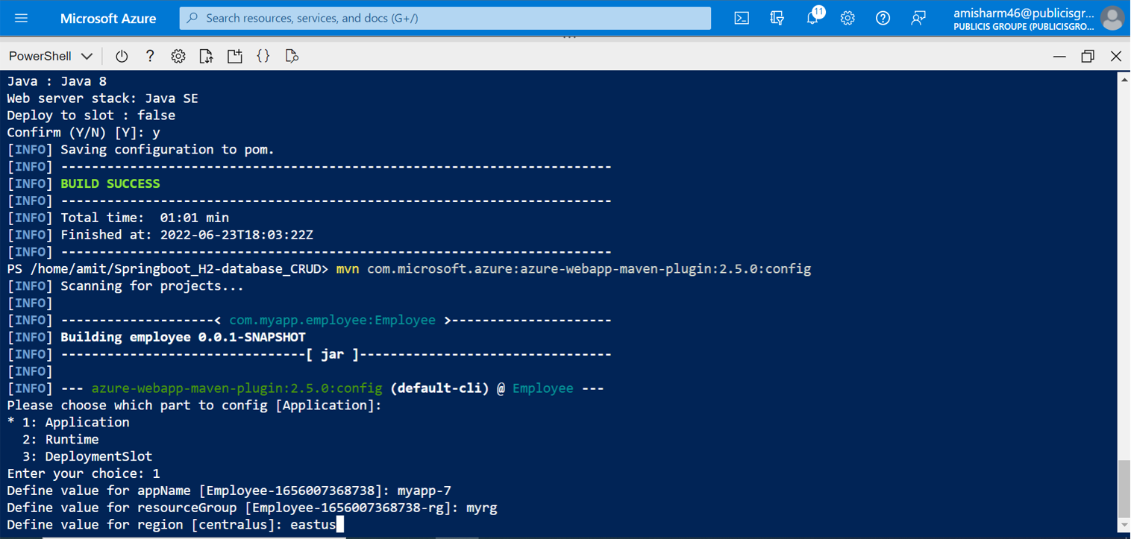

**After that again it will ask for pricing tier select the pricing tier and you application ready to deploy with the new configuration**

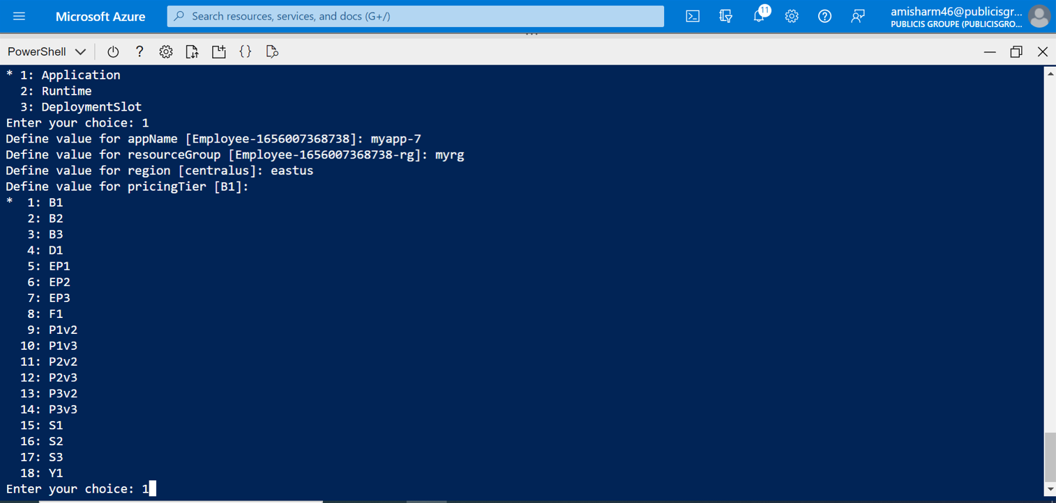

**Step#4 : After the compilation is done use below command to deploy you application to azure app service**

**“mvn package azure-webapp:deploy”**

**Wait for some time and you will see the build success ans successfully deployed message like below**

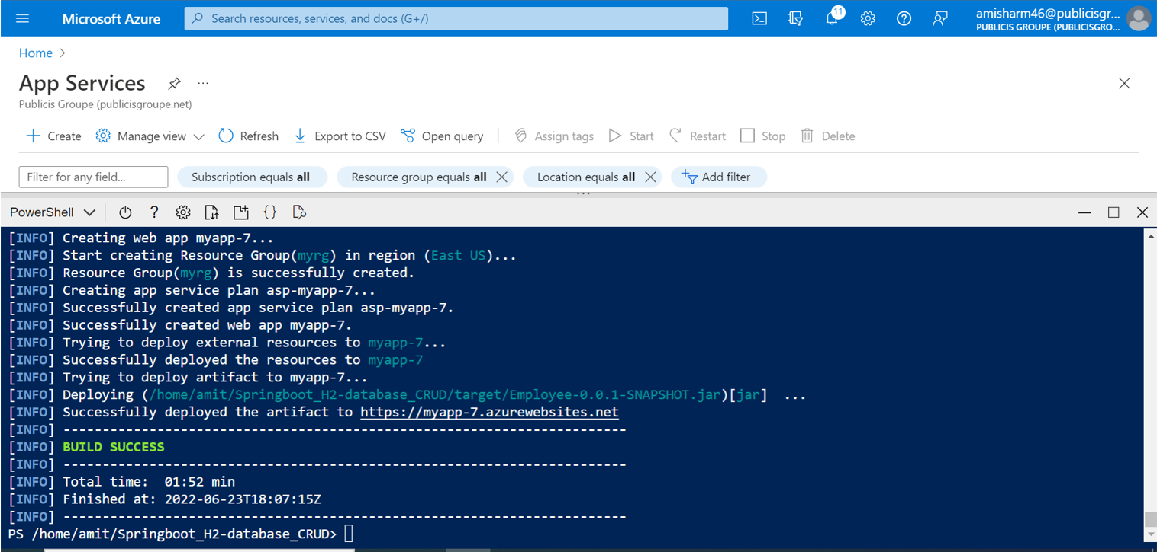

**Now check you app service the app with the given name will be created**

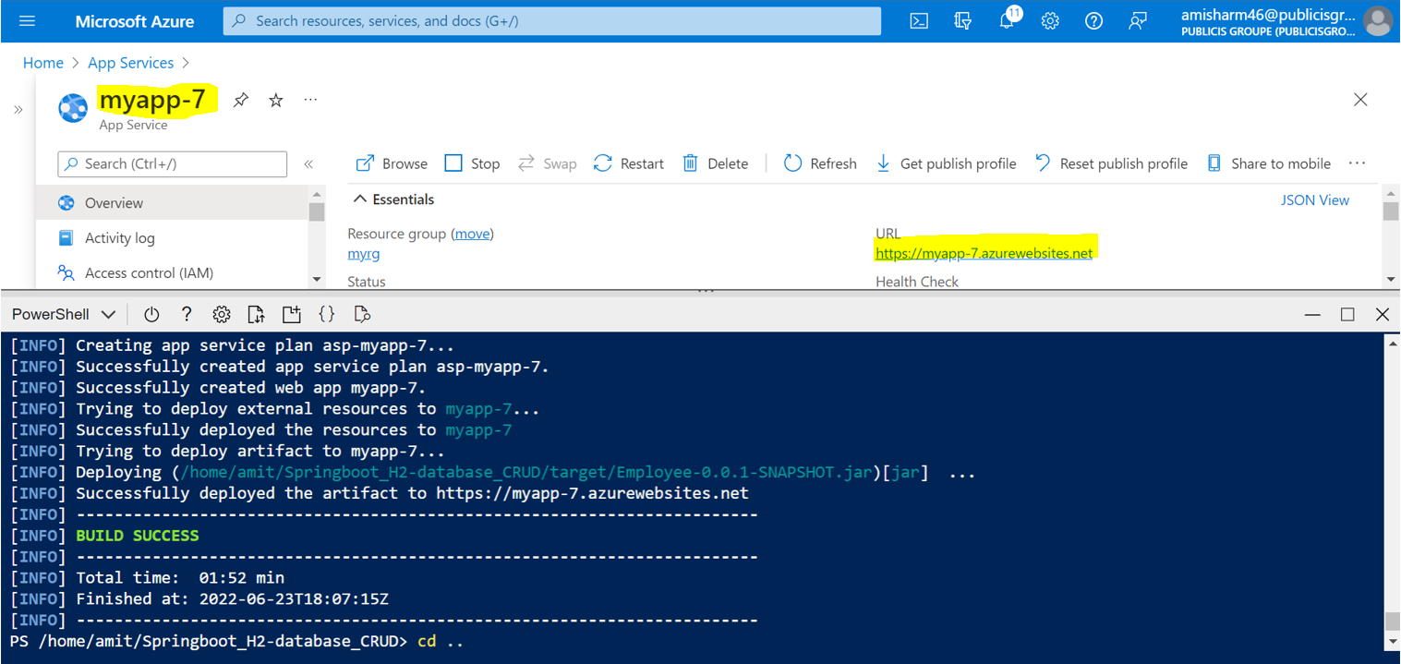

**In the right hand side we can see URL which is highlighted copy the URL and paste in the browser and u can see you application up and running like below**

